Group 25 Project

Video Game News Site

Table of Contents

Milestone

**Milestone 31**

**Appendix A (Milestone 1)1-2**

**Appendix B (Milestone 2)3-10**

**Project Milestone #3: Skeleton site with layout, tables, and forms**



We evenly divided up the workload of two pages each. The total right now for the website is 6 pages. We may or may not include more pages before the milestone but I can’t say for certain.

We haven’t done the A/B testing. We need to do this internal and external along with the actual website testing. I’ll be gathering people to do this tomorrow. Aim to do the internal tonight feb 14 and get some people from the C set to take a look at our prototype page.

A/B

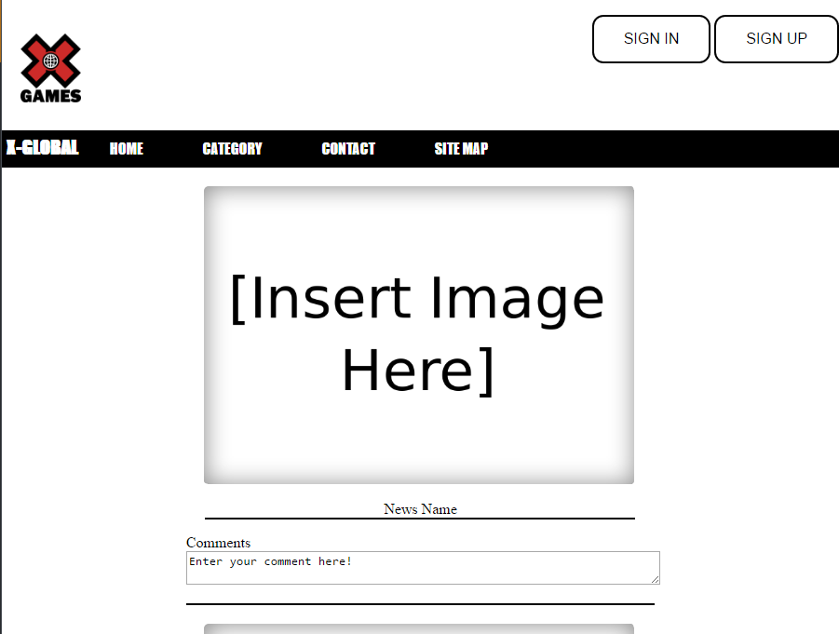

Appendix A

**Project Milestone #1: Project Proposal**

**Video Game News Website**

Project Leader: Ryan Joseph

Members: Ken Wu, Xing Wei

**Video Game News Website Overview**

The purpose of this site is just going to be a simple video game news website. Simple in a sense that the readers will just read the important facts and none of the opinions that most gaming news sites have. It will serve the readers by saving their time by reading just the important information about video game news. An example of this is just like reading cliff notes to a movie, books, television shows, etc. The site will provide an easy to read and easy to access. It will have a simple user interface with very little clutter distracting you from the articles. The site may also allow the readers to interact with one another in an open forum discussion, in the form of comments within the news article.

**Website’s Overall Goal**

Our goal as a website is to grab the attention of the gamer demographic, that are ages of between 18-49 years of age, to read our video game news site. We strive to make the video game news as our sole focal point for the site, with that being said we not focusing on any sort of reviews for video games at all. We are aiming to have a rather simple interface that will be appealing to the eyes with little to no clutter on the screen. The site’s overall look will be very similar to that of Twitter’s interface. Very simple so that the readers can scroll through the site to read just the important news about video games. The site will not operate like Twitter, such as user-generated content, we’ll being using Twitter’s webpage design as our inspirational focal point. They can also comment on the article itself by making an account with or without their e-mail address. Giving our readers a choice if they want to remain anonymous or not! We want to give our readers that option. The group is aiming to have this website fully functional by term’s end in April.

**Sites Overall Look**

The site will look similar to that of Twitter. You can scroll down the page till you hit the bottom with nothing but videogame news. Each post will include the news article along with any type of media such as pictures, gifs, and videos to compliment the news article. We’ll have a navigator that allows you to search specific device you’re interested in. A color scheme will be natural so it doesn’t strain the eyes of the reader. The news article will not be long and the commenting is going to be the same. Limiting the user’s amount of usable characters to about the same as Twitter’s of 125 characters to a comment. This is of course may lead us to using multiple pages for this because I can’t for certain that this is achievable with our current knowledge in programming. This may change in coming weeks but for now I will say it will be paged based.

**Similar Website Comparison**

The two sites that we will be critiquing will be Both Twitter and IGN. First one will be IGN: IGN, the website can be viewed [here](http://ca.ign.com/), is known in the video game industry as an entertainment news site that heavily focuses on video game news and reviews. It is a great site for all your entertainment news but not everyone wants to read entertainment related news. Some would prefer just going to IGN’s website for their gaming news and reviews. We aim to bring that news aspect from IGN and incorporate that onto our simple video game news website.

Twitter is another site that will be similar to our site, you can view the site [here](https://twitter.com/). It’s rather simple and easy to read interface is one of the highlights of their website and we’ll be implementing that aspect onto our site. Twitter’s interface allows the user to just endlessly scroll through their feed till the reach a certain point where it reaches the client’s devices limit. We’re aiming for our site to be similar, but ultimately, we might be going page oriented depending on how much programming knowledge we know by the term’s project due date.

**Workplan**

Our plan is to work closely together by having an open communication with one another. We will have many ways to get in contact with one another by using one of many means: BCIT’s e-mail, Discord, cellphones, Slacks, and cellphones. The project leader will set-up meetings to discuss about the project and/or concerns and everyone will work together on said project during the meetings. The workload will be divided up evenly among each member of the group by assigning teach member to write news article for the website. At this time the project leader will be the editor for the project till we find a suitable replacement. Also, each member will be assigned to a specific videogame device to work on by creating the webpage itself and its content. Each member is also responsible to design their webpage and making sure to keep it consistent with the theme of the site. Everyone will be working on the main page together.

Appendix B

**Project Milestone #2: Site Map and Page Design**

Site Map:

We want to keep this site as simple as possible, so we’re limiting the number of pages just to the necessary pages as described below. The main priority of the site is the video game news articles.

Wireframe:

The wireframe pages we’ve provided in the files are showing that when you enter the site that you have to sign-in/sign-up in order to access the site. We provided two options: A pop-up screen that shows up over the videogame news content, and an entirely separate sign-in page before accessing the content. We kept in mind that our programming knowledge is limited and made a separate page to reflect that incase we’re not able to program that functionality into the site. The index page also has a pop-up functionality as well. When the user is interested in a news article they see and clicks on the article, it will bring up the pop-up screen show an in-depth article along with a video/picture/gif that complements the article. The pop-up screen will also display the comment section as well. If this does not work, we’ll just provide a separate page dedicated to those articles.

Our site, at this time, will be doing a fixed position. Due to the sheer scope of this project we’ll be aiming for a simple design, as stated in the proposal. The main reason for this simplicity is that if our pop-up function doesn’t work, we have to create separate pages for each article. Later down the line, our group would like to have our navigation bar to be fluid, but that depends on the team’s schedule, knowledge, and workload. All the content will be static with the exception that our pop-up functionality for both articles and sign-in.

The site’s color scheme will be limited to mainly to black and white. The reason behind this is because the articles we write will include pictures/gif/videos will provide more than enough color for the site. The sites we’ve looked at, like Twitter and IGN, have very little color scheme. Trying to pick a colored background looks rather distracting for our site’s design and we’ve ultimately decided to leave it as white. The color black will be primarily for texts. We do not want very much distraction for our readers and limiting the color options will enhance the user’s experience.

